Special Right Triangles

NOTES

Label ALL angles and sides of the Special Right Triangles.

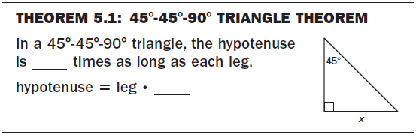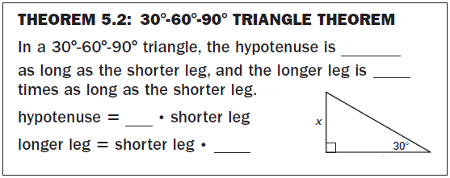

GUIDED PRACTICE

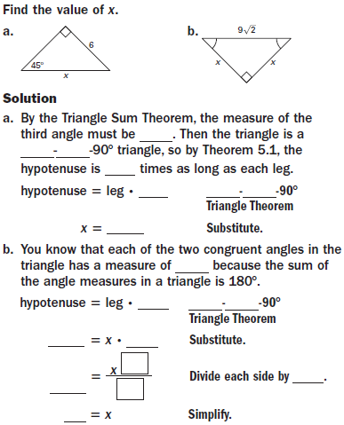

GUIDED PRACTICE cont.

