**UNIT: Right Triangle Geometry**

32 students/10th grade

**Lesson 1 –** Special Right Triangles

**Essential Question(s)**

*What is the relationship between the lengths of the legs of a 45˚-45˚-90˚ triangle and the length of the hypotenuse?*

*What are the relationships among the lengths of the sides of a 30˚-60˚-90˚ triangle?*

**Learning Objectives**

* Students will be able to determine the lengths of sides of 30˚-60˚-90˚ triangles, given at least the length of one side.
* Students will be able to determine the lengths of sides of45˚-45˚-90˚ triangles, given at least the length of one side.
* Students will be able to find the height of an equilateral triangle, given the side lengths and using 45˚-45˚-90˚ triangles.

**Learning Activities** - **6Es**

***Engage:***

You are using wood to build a skateboard ramp. You want the ramp surface to incline at an angle of *30˚* and the maximum height to be 24 inches. Draw a picture to represent the ramp and label the given information. At the end of this lesson, you will be able to find the lengths of the ramp.

***Explore*:**

Using *Geometer’s Sketchpad*, follow the steps to complete the constructions.

Draw a 45˚-45˚-90˚ triangle.

1. Construct a square. The lengths of the sides should be a whole number.
2. Label the vertices *A, B, C,* and *D*, and label each side with its length.
3. Draw the diagonal *AC* and label its length.

Q. What are the measures of the angles of the two triangles?

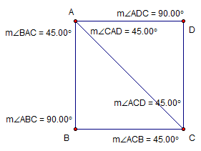

45˚-45˚-90˚ Triangle

Draw a 30˚-60˚-90˚ triangle.

1. Draw an equilateral triangle. The side lengths should be an even number.
2. Label the vertices *J, K,* and *L*, and label each side with its length.
3. Find the midpoint of side *JL*, and label the midpoint *M*. Draw a segment from *K* to *M*.

Q. What are the measures of the angles of the two triangles?

30˚-60˚-90˚ Triangle

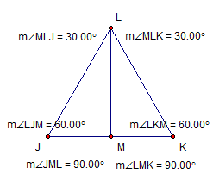

Make a table to compare the side lengths of the special right triangles with the results of two of your classmates. Do you notice a pattern? Write a conjecture based on your observations.

***Explain*:**

I will give students the opportunity to explain their previous knowledge of special right triangles to the class. Most students will have some information to share regarding properties, formulas, and theorems about right triangles. Students may also share new information they have observed and discovered during the *Explore* activity.

***Elaborate:***

Students will have the opportunity to demonstrate their knowledge on right triangles through practice and application problems. They will be given a handout (see below) for them to record notes, guided practice, and individual work.

***Evaluate:***

Students will be evaluated on their understanding through a short quiz.

***Extend:***

Continued from the Engage activity… Find the lengths of the ramp from the Warm-Up.

Suppose you want to construct another ramp at an angle of *45˚* and a maximum height of 24 inches. Draw a picture to represent the ramp and label the given information. Find the lengths of the ramp.

**Special Right Triangles**

**NOTES**

Label ALL angles and sides of the Special Right Triangles.

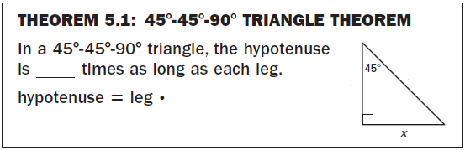 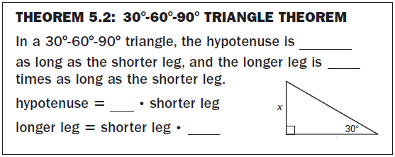

**GUIDED PRACTICE**

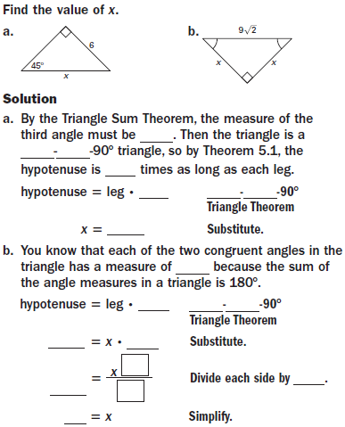

**GUIDED PRACTICE cont.**

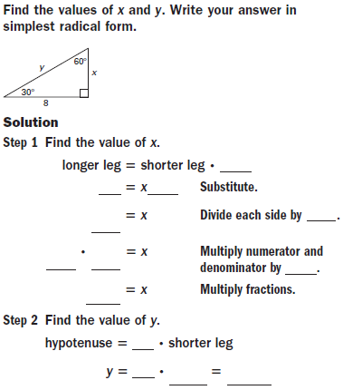

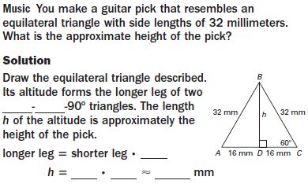

**PRACTICE**

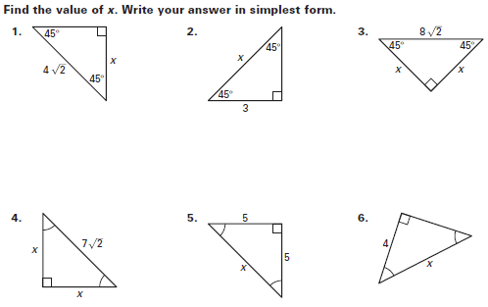

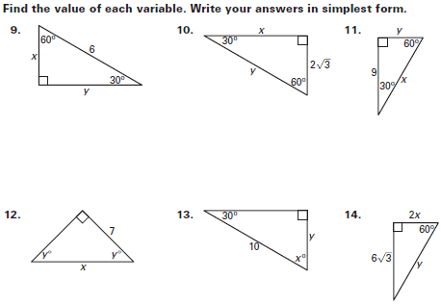

**Special Right Triangles QUIZ**

Find the value of the variable.

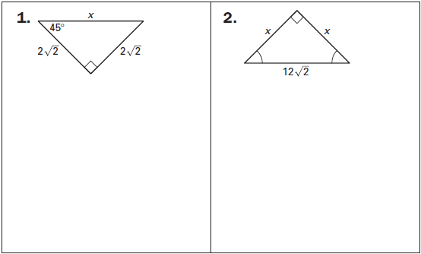

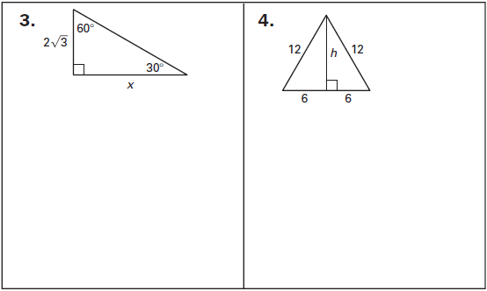

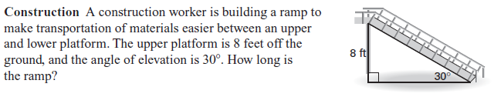**5.**







