UNIT: Right Triangle Geometry
32 students/10th grade
Lesson 2 – Apply the Tangent Ratio
Essential Question(s)
What is a trigonometric ratio?
What is the tangent ratio of a right triangle?

Learning Objectives
- Students will be able to find the tangent ratio of a right triangle, given the lengths of the sides.
- Students will be able to use the tangent of an acute angle to find a leg length, given the measure of an acute angle and the length of one side.
- Students will be able to discover the relationship of the trigonometric ratios of similar triangles.
- Students will be able to explain the relationship between the trigonometric ratios of complementary angles.
- Students will be able to solve problems using the tangent ratio.

Learning Activities - 6Es

Engage:
In this unit, students will be introduced to a new branch of mathematics that studies triangles and the relationships between their sides and the angles between these sides. This is called Trigonometry. Take a few minutes to discuss what we already know about triangles and their sides and angles. (Recall: Pythagorean Theorem)

Explore:
Students will have the opportunity to do a web search on many of the key terms of this unit. The following list of terms will be displayed on the Word Wall and students will explore the internet for definitions, pictures, examples, etc.

Key Words: trigonometry, right triangle, hypotenuse, trigonometric ratio, tangent, sine, cosine

Explain:
I will give students the opportunity to explain their new knowledge acquired during the Web Search during the Explore activity. Students will be expected to post their findings on the Class Blog. They will also be able to share the website(s) that provided the information.

Elaborate:
Students will have the opportunity to demonstrate their knowledge on the tangent ratio through practice and application problems. They will be given a handout (see below) for them to record notes, guided practice, and individual work.

Evaluate:
Students will be evaluated on their understanding through the practice worksheet.

Extend:
Continued from the Explain activity… Students will partake in written discourse on the Class Blog. Students are strongly encouraged to discuss and share ideas about trigonometry. Students will be expected to make one original post and comment on a minimum of two other posts. Students will also be graded for participation on the Class Blog.

Tangent Ratio

NOTES

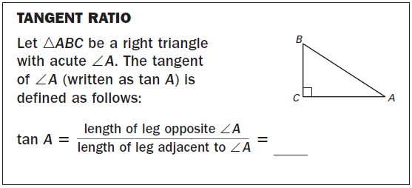

GUIDED PRACTICE

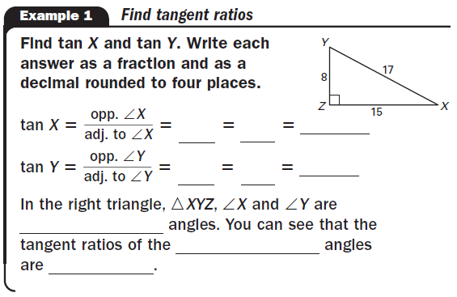
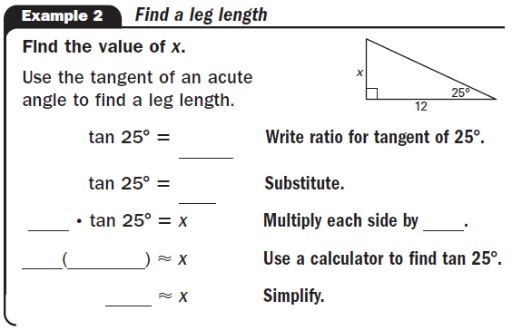

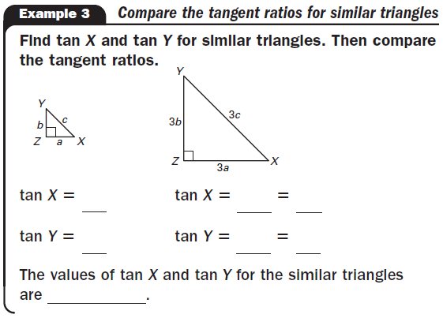

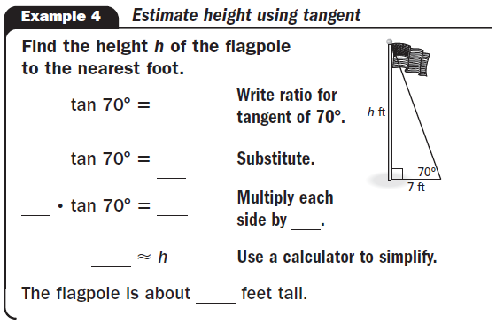

PRACTICE

