UNIT: Right Triangle Geometry
32 students/10th grade
Lesson 3 – Apply the Sine and Cosine Ratios
Essential Question(s)
What is the sine ratio in a right triangle?
What is the cosine ratio in a right triangle?

Learning Objectives
- Students will be able to find the sine ratio of a right triangle, given the lengths of the sides.
- Students will be able to find the cosine ratio of a right triangle, given the lengths of the sides.
- Students will be able to find the sine and cosine ratios for similar triangles by identifying complementary angles.
- Students will be able to use the trigonometric ratios to find side lengths of right triangles, given the measure of an acute angle and the length of one side.

Learning Activities - 6Es

Engage:
Students will respond to the following questions in a journal entry. Their responses will not be shared with the class, but this activity will encourage thoughtful reflections on previous lessons and where we are headed for this lesson.
- Based on what you have learned about the tangent ratio, can you predict what the sine and cosine ratios will be?
- What are some ways that we can all remember the trigonometric ratios?

Explore:
Go to the following website: http://www.mathsisfun.com/sine-cosine-tangent.html
Take about 5 or 6 minutes to explore this website. Think about what you are already know and things that are new to you. Be sure to check out the cool illustrations!

Explain:
I will give students the opportunity to explain what they learned from the website during the Explore activity. We will have a short class discussion on the three different trigonometric ratios from this unit, and discuss ways that we can remember them.

Elaborate:
Students will have the opportunity to demonstrate their knowledge on sine and cosine ratios through practice and application problems. They will be given a handout (see below) for them to record notes, guided practice, and individual work.

Evaluate:
Students will be evaluated on their understanding through a practice worksheet that will be completed individually during class, and turned in for a grade.

Extend:
Students will be encouraged to go to the Class Website to view the Class Blog and discuss what we have learned so far during this unit. As we are nearing the end of the unit, it is important that students ask any questions about the content covered in each lesson.

Apply the Sine and Cosine Ratios
NOTES
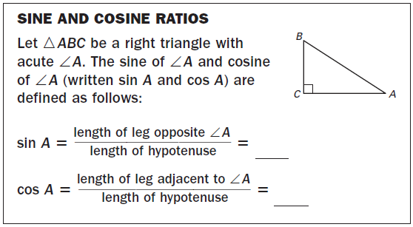

GUIDED PRACTICE
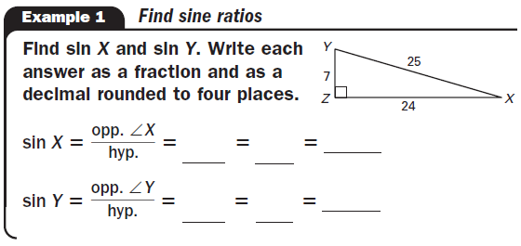
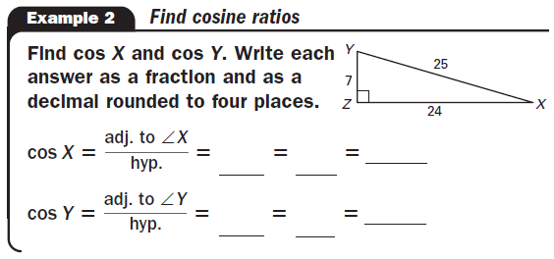
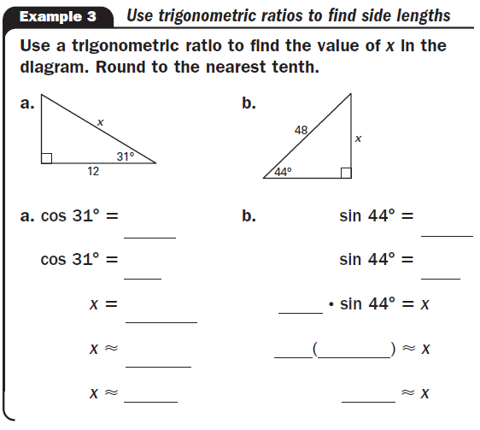
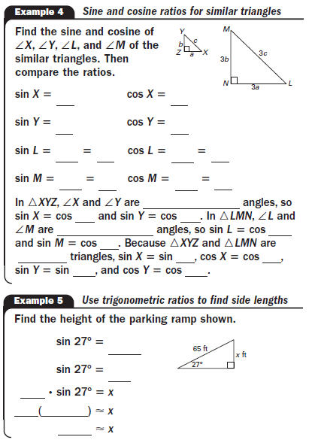

Apply the Sine and Cosine Ratios
PRACTICE
