Trigonometry Project

For this project you may choose one of the following two options. Also please attach this sheet as the front cover to your project since this is also your scoring rubric.

Project #1: Calculating the Angle of Elevation of the Sun

Trigonometry is all around us! Right triangles can be found in many daily situations. In this project you will apply your knowledge of trigonometry to shadows in order to calculate the angle of elevation to the sun at different times of day.

To calculate the angle of elevation of the sun use following the procedure:
- Measure your height and the length of the shadow you cast at two different times of day (at least 3 hours apart)
- Record the times and measurements (with units)
- Draw the right triangle in this scenario
- Label the sides of your drawing with your measurements and angle of elevation
- Solve for the angle of elevation while clearly showing all your steps

Don’t forget that you need to do the procedure above twice for two different times of day!
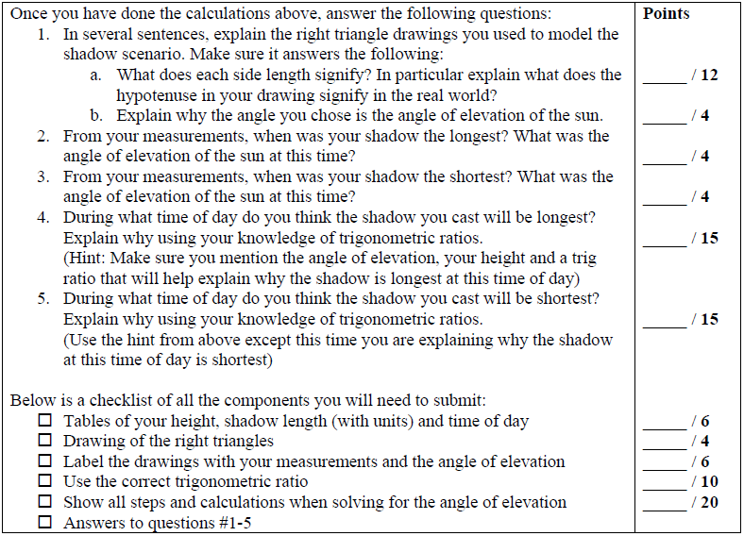

Project #2: Developing A Trigonometry Table

A trigonometry table is a powerful tool used by mathematicians and was first developed by Hipparchus (Ἵππαρχος) who lived in the 2nd century BC. In this project you too will be creating a trigonometry table. However, unlike Hipparchus, we already know three important trigonometric ratios that exist (later in high school you will learn three more and yet another three in college).

To create a trigonometry table use following the procedure:
- Write down the formulas for sine, cosine and tangent.
- For each of the following angle measurements (5º, 15º, 30º, 45º, 60º, 75º, 85º) draw a right triangle with one acute angle of that measurement. Make sure to use rulers and protractors and be as exact as possible in your constructions.
- For each triangle label the side opposite, adjacent and the hypotenuse in relation to the acute angle (5º, 15º, 30º, 45º, 60º, 75º, 85º).
- Measure the length of each side and write that on your triangles.
- Calculate sine, cosine and tangent for the angles 5º, 15º, 30º, 45º, 60º, 75º, 85º using the triangles and side lengths you just measured. Show all your work and calculations!
- Present your calculations of sine, cosine and tangent and the angles in a table like the trig table handed out in class.

(Note: You can also use that trig table to see if your answers are good approximations. If there is a little error, that is due to inaccuracies in measurement. If there is a lot of error, that is a problem).
